1. Problem Statement

Given a shorten url , system should able to return the valid long url.

1. Requirement

Accept a short URL as input and return a original long URL

Should accept only valid short URL’s

1. Endpoint

Post hostname/api/Url/getOrignalUrl

1. Flow diagram

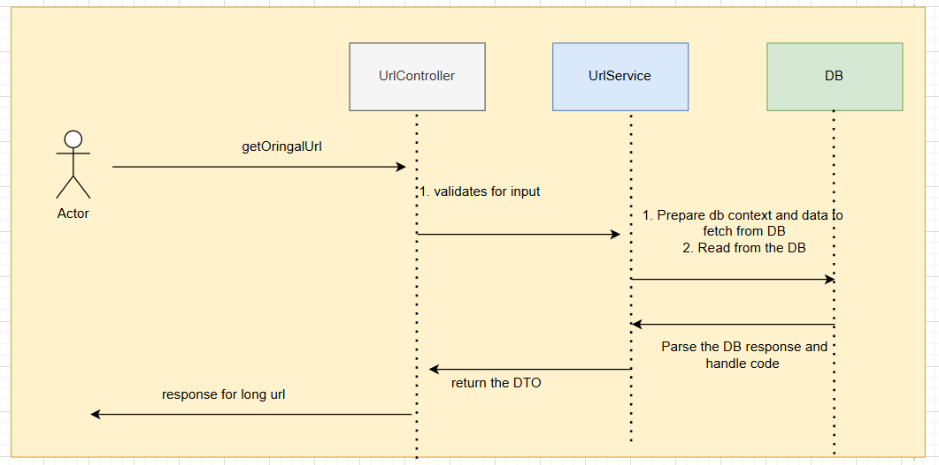

1. Example

Request :

Post host/api/Url/getOrignalUrl

{

"shortUrl": "newgen.ly4ldrhY"

}

Response :

Body

{

"message": null,

"longUrl": "https://www.perplexity.ai/search/asp-net-kv7L.FaiTjS5L.Fh10NgUg",

"shortUrl": "newgen.ly4ldrhY"

}

1. Other